Question 1

The accounts available are:

* Fixed
* FixedLT
* 1-Year Indexed Account
* 1-Year No Cap Indexed Account
* 1-Year High Cap Plus Indexed Account
* Variable Account

Question 2

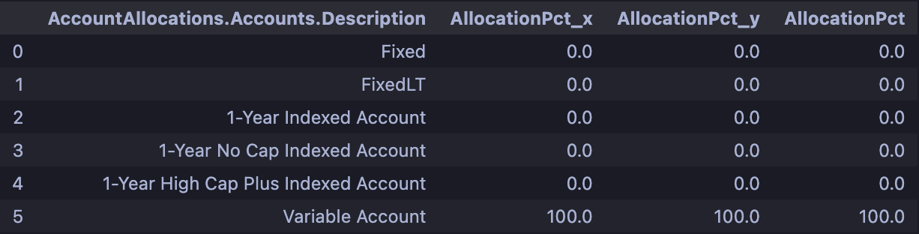

Question 3

The policyholder from the illustration PDF has acquired the Overloan Protection 3 Rider and the Terminal Illness Rider.

The Overloan Protection 3 Rider can be exercised to ensure that the policy will not lapse. A lapse in life insurance policy usually occurs when the policyholder has missed a premium payment for coverage. This rider is an automatic rider.

The Terminal Illness Rider allows for the acceleration of the death benefits being paid to the insured if they are diagnosed as terminally ill with a life expectancy of 12 months or less. This rider is an optional rider.